Unreal Engine Character Movement testing Cole Dorman
I had finally figured out an exciting idea to try to implement which was trying to go ahead and pre record a sequence of moves from a player, and then play that back to demonstrate live how different settings on CharacterMovementComponent affect how movement looks.
However shortly into trying to learn this and follow the official documentation I attempted to start recording by pressing the hotkey to initialize it which is ALT + P. This causes a replicatable instant crash whenever recording is initialized like that. After looking into it further I found that it just was unable to find something to record, and instead of not recording and providing user feedback (like a warning or error) it just hard crashed the engine! So I did more digging, finally I got an idea of how to set things up properly via a tutorial I had found however, after setting things up so in my scene I had disabled pawn spawning so that we don’t have interference and then connected the character which’s control was disabled to the recorder, I started the sim then flew over, and possessed the character, and pressed record. Once again, the engine lovingly crashed.
After about another hour of trying to figure out whats going on I finally got something to work and a short recording, so I was pretty excited, then when I stopped recording I was met with the following: 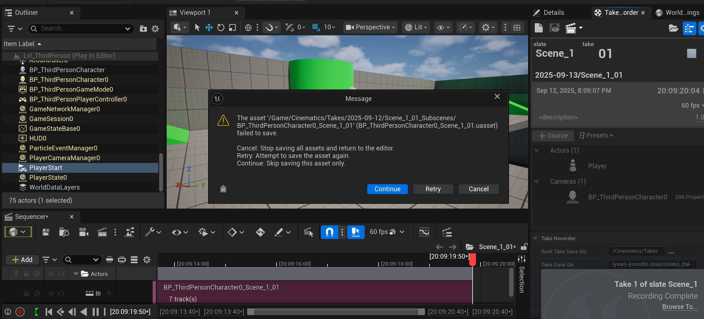
So I had figured that wouldn’t work but apparently it did work despite being unable to save. Which is fascinating, the team must be 2 steps ahead at all times, even when the engine says it failed to save, it did. My theory that I investigated was that this was due to the engine being confused as the player actor isn’t in the editor until the game starts, then it spawns. There is no way to confirm this for certain without spending hours so I will be assuming that is the case.
After another hour or so I finally got something working to replay the actual movement I had done, but ran into many more issues along the way especially regarding having multiple characters in the level at once, who were technically players.
My final results of all the suffering are included in this submission in mp4 format. This is just my documentation of my process as I worked.

